SQL Assignment

**Creating TABLES**

CREATE TABLE BOATS (

REG_NUM VARCHAR(7),

YEAR NUMERIC(4),

MAKE VARCHAR(10),

LENGTH NUMERIC(4,1),

BEAM NUMERIC(3),

CONSTRAINT BOATS_PK PRIMARY KEY (REG_NUM),

CONSTRAINT BOATS_YR_CC CHECK (YEAR > 1900),

CONSTRAINT BOATS_LENGTH_CC CHECK (LENGTH > 0),

CONSTRAINT BOATS_BEAM_CC CHECK (BEAM > 0)

);

INSERT INTO BOATS VALUES ('WN123AB',1977,'Hunter',25,96);

INSERT INTO BOATS VALUES ('WN234CD',1999,'Calabria',23,103);

INSERT INTO BOATS VALUES ('WN234EF',1962,'Del Mar',16,72);

INSERT INTO BOATS VALUES ('WN456GH',1957,'Harvey',13.5,70);

INSERT INTO BOATS VALUES ('WN567IJ',1997,'Seadoo',9,46);

INSERT INTO BOATS VALUES ('WN678JL',1996,'Bayliner',47,179);

CREATE TABLE ENGINE_TYPES(

MAKE VARCHAR(12),

MODEL VARCHAR(12),

HP NUMERIC(4,1),

FUEL VARCHAR(6),

CONSTRAINT ENGINE_TYPES_PK PRIMARY KEY (MAKE, MODEL),

CONSTRAINT ENGINE_TYPES_HP_CC CHECK (HP >= 0),

CONSTRAINT ENGINE_TYPES_FUEL_CC CHECK (FUEL IN ('Gas', 'Petrol','Diesel'))

);

INSERT INTO ENGINE_TYPES VALUES ('Clinton','K990',9.9,'Gas');

INSERT INTO ENGINE_TYPES VALUES ('Mercruiser','350MagMPI',300,'Gas');

INSERT INTO ENGINE_TYPES VALUES ('Mannem','Arjun',30,'Gas');

INSERT INTO ENGINE_TYPES VALUES ('Tohatsu','M50CEPTS',50,'Gas');

INSERT INTO ENGINE_TYPES VALUES ('Rotax','720CC',85,'Gas');

INSERT INTO ENGINE_TYPES VALUES ('Hino','W06DTA',310,'Diesel');

CREATE TABLE ENGINES(

SERIAL_NUM VARCHAR(7),

YEAR NUMERIC(4),

MAKE VARCHAR(12),

MODEL VARCHAR(12),

CONSTRAINT ENGINES_PK PRIMARY KEY (SERIAL_NUM),

CONSTRAINT ENGINES_YR_CC CHECK (YEAR > 1900),

CONSTRAINT ENGINES_FK FOREIGN KEY (MAKE, MODEL) REFERENCES ENGINE_TYPES (MAKE,MODEL) ON DELETE SET NULL

);

INSERT INTO ENGINES VALUES ('C1075',1975,'Clinton','K990');

INSERT INTO ENGINES VALUES ('M30099',1999,'Mercruiser','350MagMPI');

INSERT INTO ENGINES VALUES ('M3060',1962,'Mannem','Arjun');

INSERT INTO ENGINES VALUES ('T5090',1990,'Tohatsu','M50CEPTS');

INSERT INTO ENGINES VALUES ('R8596',1997,'Rotax','720CC');

INSERT INTO ENGINES VALUES ('H31096A',1996,'Hino','W06DTA');

INSERT INTO ENGINES VALUES ('H31096B',1996,'Hino','W06DTA');

CREATE TABLE BOAT_ENGINES(

ENGINE_SERIAL_NUM VARCHAR(7),

BOAT_ID VARCHAR(7),

CONSTRAINT BOAT_ENGINES_SERIALNUM_FK FOREIGN KEY (ENGINE_SERIAL_NUM) REFERENCES ENGINES (SERIAL_NUM) ON DELETE SET NULL,

CONSTRAINT BOAT_ENGINES_BOATID_FK FOREIGN KEY (BOAT_ID) REFERENCES BOATS (REG_NUM) ON DELETE SET NULL

);

INSERT INTO BOAT_ENGINES VALUES ('C1075','WN123AB');

INSERT INTO BOAT_ENGINES VALUES ('M30099','WN234CD');

INSERT INTO BOAT_ENGINES VALUES ('M3060','WN234EF');

INSERT INTO BOAT_ENGINES VALUES ('T5090','WN456GH');

INSERT INTO BOAT_ENGINES VALUES ('R8596','WN567IJ');

INSERT INTO BOAT_ENGINES VALUES ('H31096A','WN678JL');

INSERT INTO BOAT_ENGINES VALUES ('H31096B','WN678JL');

CREATE TABLE BOAT_REGISTRY (

CUST_ID SERIAL PRIMARY KEY,

L_NAME VARCHAR(255),

F_NAME VARCHAR(255),

ADDRESS VARCHAR(255),

ZIP VARCHAR(10),

EMAIL VARCHAR(255),

BALANCE NUMERIC CHECK (BALANCE >= 0),

BOAT_ID VARCHAR(10) REFERENCES BOATS (REG_NUM) ON DELETE SET NULL

);

INSERT INTO BOAT_REGISTRY (L_NAME, F_NAME, ADDRESS, ZIP, EMAIL, BALANCE, BOAT_ID)

VALUES ('Bach', 'David', '2039 76th St.', '10001', 'david@davidbach.com', 1250.00, 'WN123AB');

INSERT INTO BOAT_REGISTRY (L_NAME, F_NAME, ADDRESS, ZIP, EMAIL, BALANCE, BOAT_ID)

VALUES ('Ramsey', 'Dave', '8391 Main St.', '37212', 'dave@daveramsey.com', 99.99, 'WN234CD');

**UPDATE BOAT_REGISTRY**

SET L_NAME = 'Mannem', F_NAME = 'Mallikarjuna', EMAIL = 'mannemm@mail.gvsu.edu', ADDRESS = '304 Manzana Ct', ZIP = '49534'

WHERE F_NAME='Dave';

SELECT * FROM BOAT_REGISTRY;

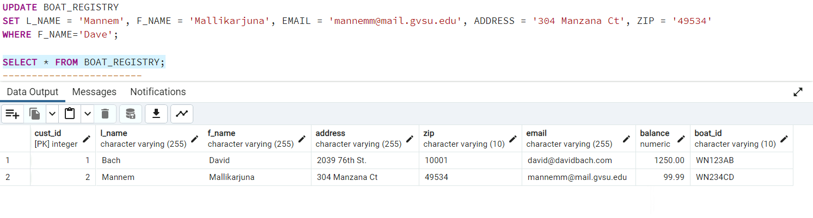

-------------------------------------------------------------------------------------------------------------------------------

---1. ***Select all the unique/distinct years within the BOATS table.***

SELECT DISTINCT YEAR FROM BOATS;

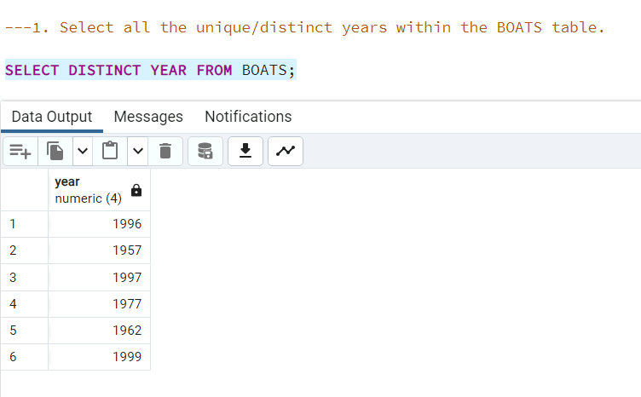

---2. ***Select all data for the boat 'WN123AB' from the BOATS table.***

SELECT * FROM BOATS WHERE REG_NUM = 'WN123AB';

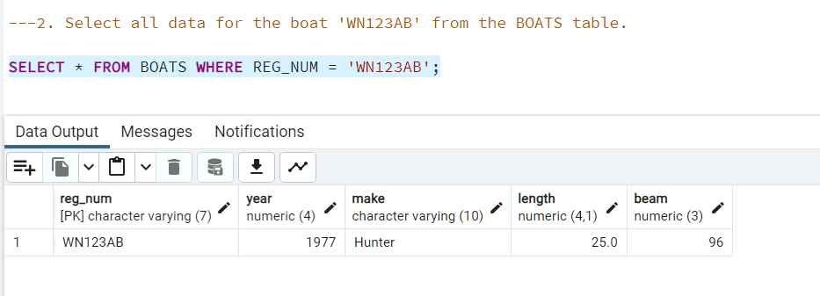

---3. ***Select all data for the BOATS with a '23' somewhere in the REG_NUM from the BOATS table.***

SELECT * FROM BOATS WHERE REG_NUM LIKE '%23%';

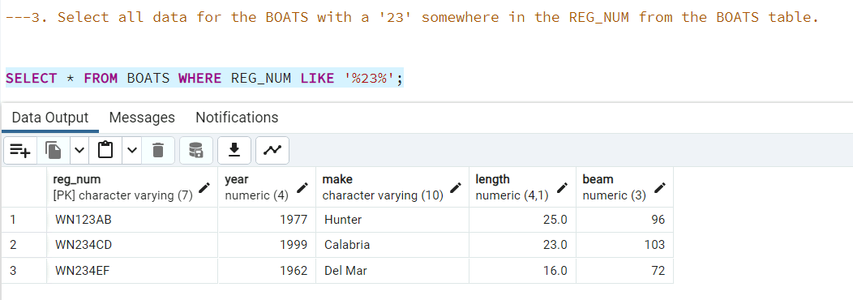

---4. ***Select the BOATS that are classics (made before 1978) or large (length over 20 feet) from the BOATS table.***

SELECT * FROM BOATS WHERE YEAR < 1978 OR LENGTH > 20;

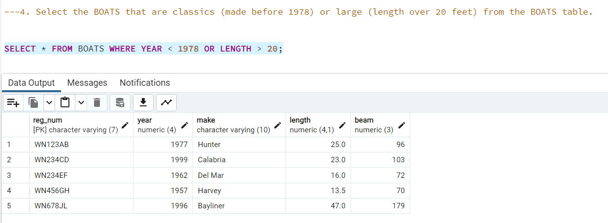

---5. ***Select all data for low power engines (ENGINE_TYPES with less than 100 HP) from the ENGINE_TYPES table.***

SELECT * FROM ENGINE_TYPES WHERE HP < 100;

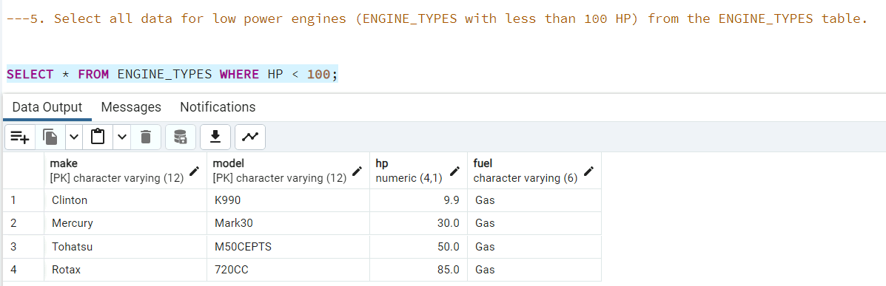

---6. ***Select all data for Gas engines over 100 HP from the ENGINE_TYPES table.***

SELECT * FROM ENGINE_TYPES WHERE FUEL = 'Gas' AND HP > 100;

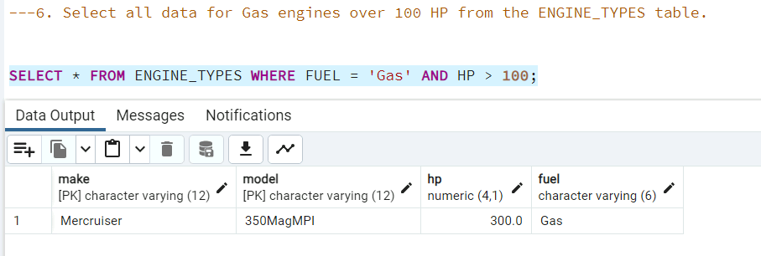

---Aggregate Queries:

---7. ***Count the number of 'Gas' fueled engines from the ENGINE_TYPES table.***

SELECT COUNT(*) FROM ENGINE_TYPES WHERE FUEL = 'Gas';

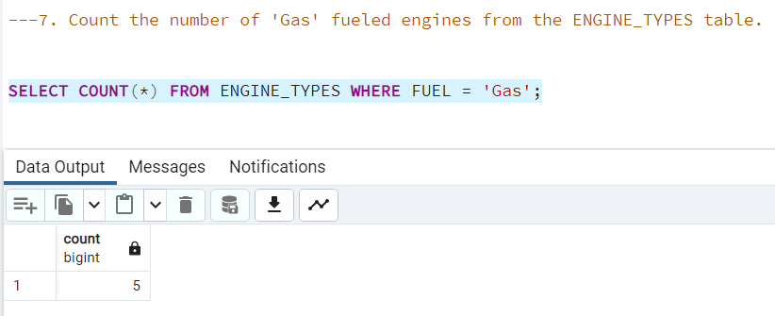

---8. ***Count the number of 'Gas' fueled engines with more than 70 HP from the ENGINE_TYPES table.***

SELECT COUNT(*) FROM ENGINE_TYPES WHERE FUEL = 'Gas' AND HP > 70;

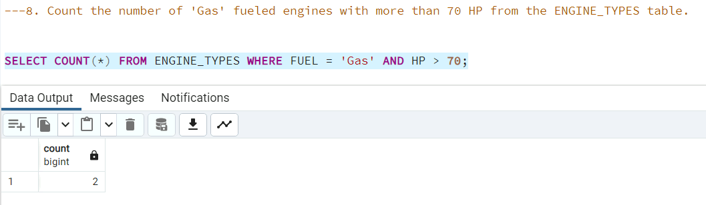

---9. ***Provide the average HP of 'Gas' fueled engines from the ENGINE_TYPES table.***

SELECT AVG(HP) FROM ENGINE_TYPES WHERE FUEL = 'Gas';

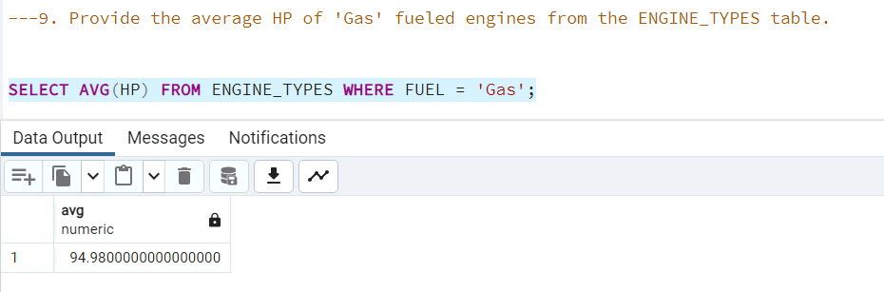

---10. ***What is the average boat length?***

SELECT AVG(LENGTH) FROM BOATS;

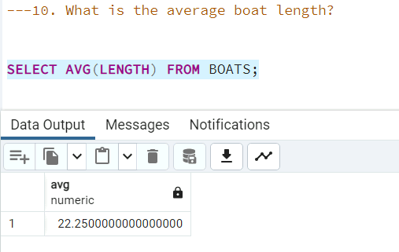

---11. ***Count the boats made in the 1990s from the BOATS table.***

SELECT COUNT(*) FROM BOATS WHERE YEAR BETWEEN 1990 AND 1999;

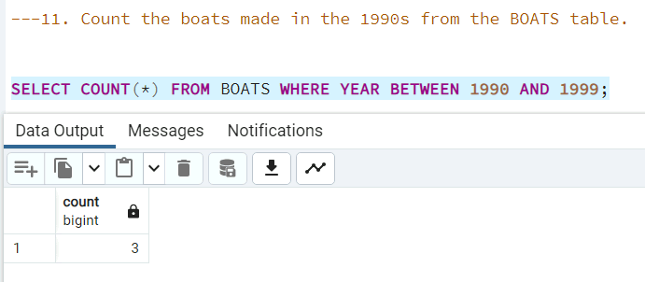

---Multi-table Joins:

---12. ***What is the total HP for every specific ENGINE (SERIAL_NUM)?***

SELECT E.SERIAL_NUM, SUM(ET.HP) AS "Total HP" FROM ENGINES E

INNER JOIN ENGINE_TYPES ET ON E.MAKE = ET.MAKE AND E.MODEL = ET.MODEL GROUP BY E.SERIAL_NUM;

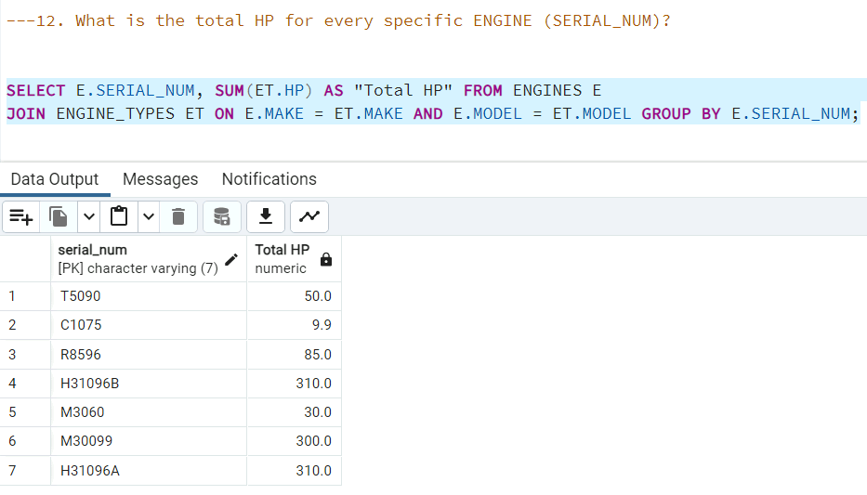

---13. ***What are the serial numbers for only the 'Gas' fueled engines?***

SELECT E.SERIAL_NUM, ET.FUEL FROM ENGINES E

INNER JOIN ENGINE_TYPES ET ON E.MAKE = ET.MAKE AND E.MODEL = ET.MODEL

WHERE ET.FUEL = 'Gas';

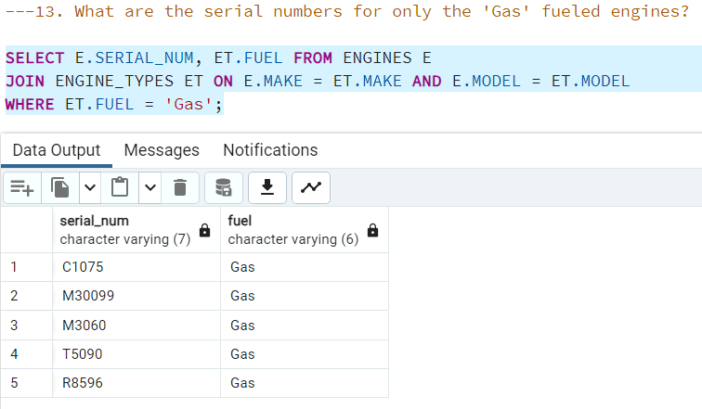

---14. ***Which BOATS have over 100 total HP?***

SELECT B.REG_NUM, SUM(ET.HP) AS "Total HP" FROM BOATS B

JOIN BOAT_ENGINES BE ON B.REG_NUM = BE.BOAT_ID

JOIN ENGINES E ON BE.ENGINE_SERIAL_NUM = E.SERIAL_NUM

JOIN ENGINE_TYPES ET ON E.MAKE = ET.MAKE AND E.MODEL = ET.MODEL

GROUP BY B.REG_NUM HAVING SUM(ET.HP) > 100;

*---OR MORE EFFICIENTLY*

SELECT BE.BOAT_ID, SUM(ET.HP) AS "Total HP" FROM BOAT_ENGINES BE

JOIN ENGINES E ON BE.ENGINE_SERIAL_NUM = E.SERIAL_NUM

JOIN ENGINE_TYPES ET ON E.MAKE = ET.MAKE AND E.MODEL = ET.MODEL

GROUP BY BE.BOAT_ID HAVING SUM(ET.HP) > 100;

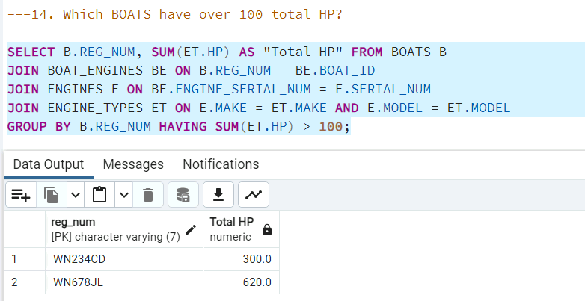

---Sub-Queries:

---***15. Which newer full-sized BOATS (LENGTH > 20 and YEAR > 1990) also have an ENGINE with over 300 HP?***

SELECT REG_NUM FROM BOATS WHERE LENGTH > 20 AND YEAR > 1990

AND REG_NUM IN (

SELECT BE.BOAT_ID FROM BOAT_ENGINES BE

JOIN ENGINES E ON BE.ENGINE_SERIAL_NUM = E.SERIAL_NUM

JOIN ENGINE_TYPES ET ON E.MAKE = ET.MAKE AND E.MODEL = ET.MODEL

WHERE ET.HP > 300

);

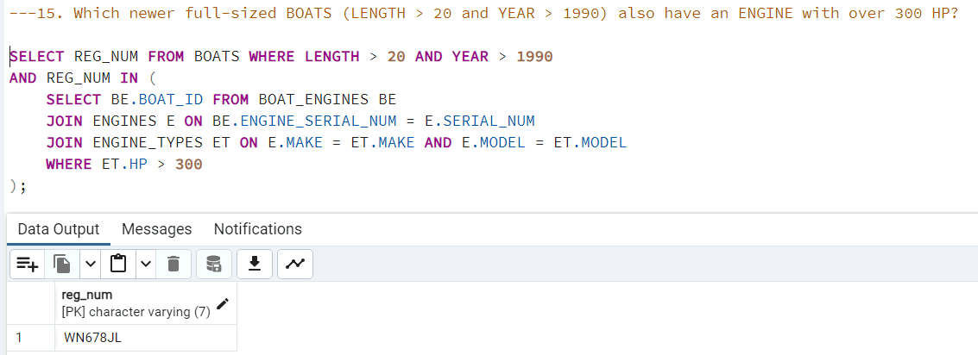

---***16. Which BOATS have a LENGTH longer than the average boat and are classic boats built before 1978?***

SELECT REG_NUM FROM BOATS

WHERE LENGTH > (SELECT AVG(LENGTH) FROM BOATS) AND YEAR < 1978;

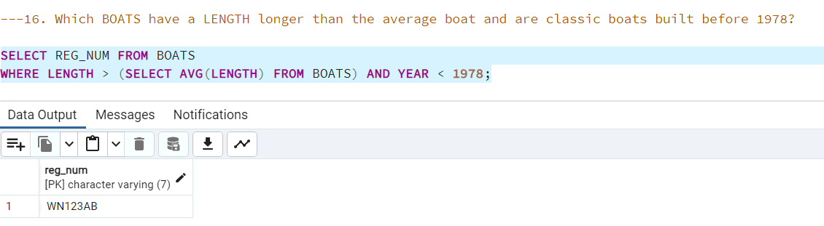

---Set Operations:

---***17. Use a set operation (UNION, INTERSECT, or MINUS) statement to find the ENGINE_TYPES (e.g., MAKE, MODEL) that use 'Gas' FUEL and were produced before 1989.***

SELECT MAKE, MODEL FROM ENGINE_TYPES WHERE FUEL = 'Gas' INTERSECT

SELECT MAKE, MODEL FROM ENGINE_TYPES WHERE YEAR < 1989;

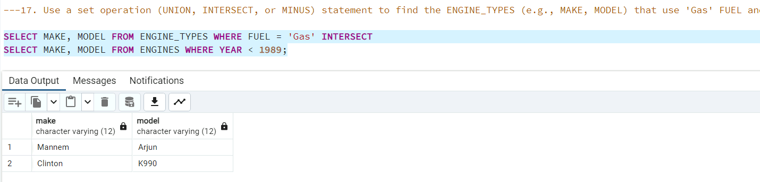

---Additional DML Statements:

---***18. Update each 'Gas' fuel type to 'Petrol' in the ENGINE_TYPES table.***

UPDATE ENGINE_TYPES

SET FUEL = 'Petrol' WHERE FUEL = 'Gas';

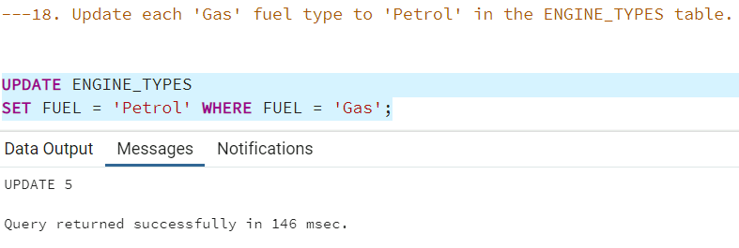

---***19. Delete boat 'WN123AB' from the BOATS table.***

DELETE FROM BOATS WHERE REG_NUM = 'WN123AB';

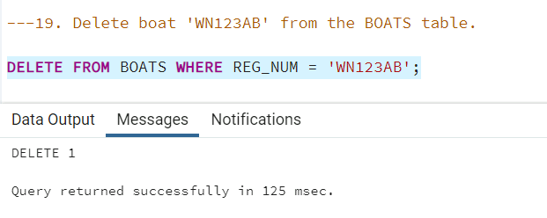

---DDL - View Statements:

---***20. Create a view that contains only the ENGINE_TYPES records that run on 'Petrol'.***

CREATE VIEW PETROL_ENGINES_VIEW AS

SELECT * FROM ENGINE_TYPES WHERE FUEL = 'Petrol';

SELECT * FROM PETROL_ENGINES_VIEW;

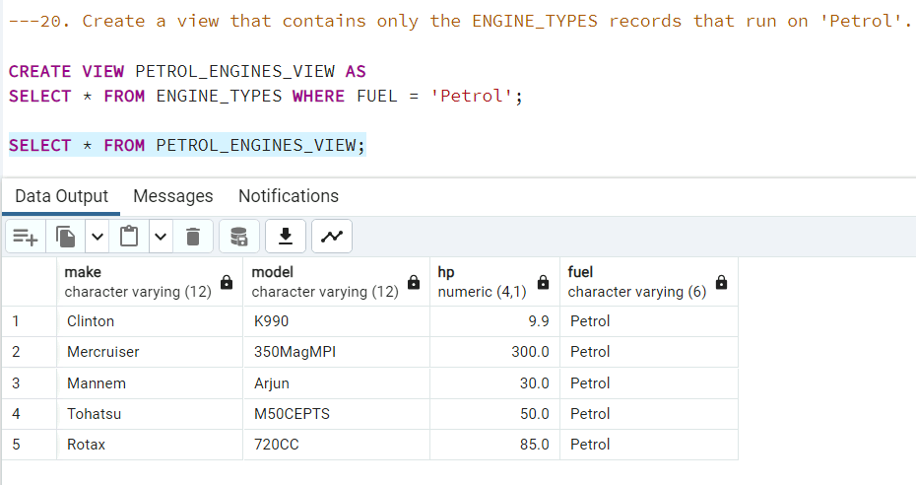

---***21. Create a view that lists all pertinent information about your boat, including your name, the boat's name, the engine type, and engine horsepower.***

CREATE VIEW MY_BOAT_VIEW AS

SELECT BR.L_NAME, BR.F_NAME, B.MAKE AS BOAT_MAKE, B.LENGTH AS BOAT_LENGTH, E.MODEL AS ENGINE_MODEL, ET.HP AS ENGINE_HP

FROM BOAT_REGISTRY BR

JOIN BOATS B ON BR.BOAT_ID = B.REG_NUM

JOIN ENGINES E ON B.REG_NUM = E.SERIAL_NUM

JOIN ENGINE_TYPES ET ON E.MAKE = ET.MAKE AND E.MODEL = ET.MODEL;

